# Usecase Diagram

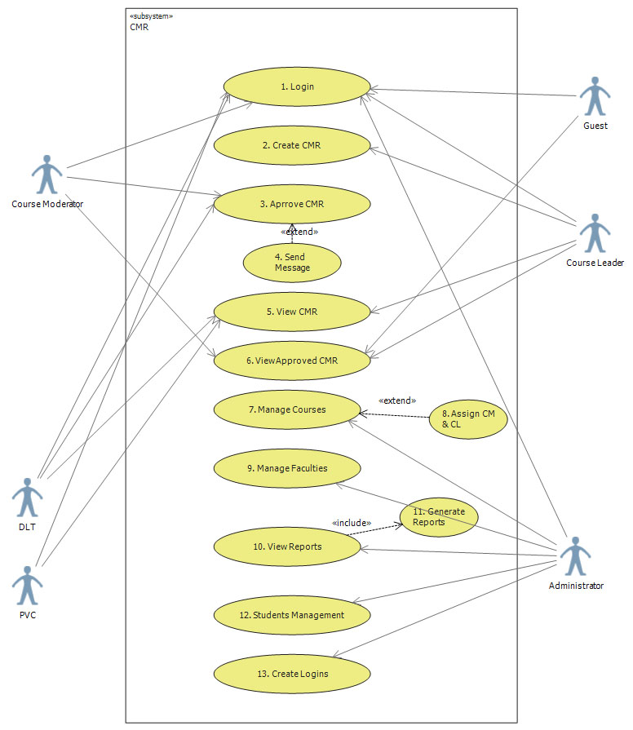

Figure 1- Use case scenarios are based on this diagram

|  |  |
| --- | --- |
| ***UseCase number*** | 01 |
| ***UseCase Name*** | Log In |
| ***Actors*** | any |
| ***Pre-Condition*** | - |
| ***Flow of events*** | 1. Show login form 2. Ask for username and password 3. Validate password 4. Set new session for the user |
| ***Alternative Path*** | in 3, if validation failed show an error |
| ***Post Condition*** | User logged in to system |
| ***Extension points*** | - |

|  |  |
| --- | --- |
| ***UseCase number*** | 02 |
| ***UseCase Name*** | Create CMR |
| ***Actors*** | CL |
| ***Pre-Condition*** | User must be logged in and must have a course assigned to him.  User must be a Course Leader |
| ***Flow of events*** | 1. User create CMR header sheet 2. Save it 3. Add data to CMR 4. Repeat 3 as necessary 5. Go to CRM View 6. Submit it |
| ***Alternative Path*** | - |
| ***Post Condition*** | CM is notified |
| ***Extension points*** | - |

|  |  |
| --- | --- |
| ***UseCase number*** | 03 |
| ***UseCase Name*** | Approve CMR |
| ***Actors*** | CM,DLT |
| ***Pre-Condition*** | User must be logged in and must either be CM or DLT |
| ***Flow of events*** | 1. View notified CMR 2. Type in the comment area 3. Select approve or reject 4. Save |
| ***Alternative Path*** | - |
| ***Post Condition*** | 1. If actor is a CM then DLT is notified to approve it  2. if actor is DLT then CM,CL,PVC will notified on approve  3. if rejected 1 and 2 is ignored |
| ***Extension points*** | Use case 4 – send message |

|  |  |
| --- | --- |
| ***UseCase number*** | 04 |
| ***UseCase Name*** | Send Message |
| ***Actors*** | System |
| ***Pre-Condition*** | Send message notification received |
| ***Flow of events*** | 1. Collect email addresses 2. Prepare message 3. Send the email |
| ***Alternative Path*** | - |
| ***Post Condition*** | - |
| ***Extension points*** | - |

|  |  |
| --- | --- |
| ***UseCase number*** | 05 |
| ***UseCase Name*** | View CMR |
| ***Actors*** | CL, CM, DLT, PVC, Admin |
| ***Pre-Condition*** | User must be logged in |
| ***Flow of events*** | 1. Display related CMRs 2. CL & CM still see the reports that are related to them |
| ***Alternative Path*** | - |
| ***Post Condition*** | - |
| ***Extension points*** | - |

|  |  |
| --- | --- |
| ***UseCase number*** | 06 |
| ***UseCase Name*** | View approved CMRs |
| ***Actors*** | All logged in users |
| ***Pre-Condition*** | Users must be logged in |
| ***Flow of events*** | 1. Find the CMR from the list 2. Apply search filters if needed 3. View the CMR |
| ***Alternative Path*** | in 2, If search filters applied, display results accordingly |
| ***Post Condition*** | - |
| ***Extension points*** | - |

|  |  |
| --- | --- |
| ***UseCase number*** | 07 |
| ***UseCase Name*** | Manage Courses |
| ***Actors*** | PVC, DLT, Admin |
| ***Pre-Condition*** | Users must be logged in |
| ***Flow of events*** | 1. Show options to create a course 2. Display Edit options |
| ***Alternative Path*** | in 1, if user wants to create a new course, display a form  In 2, if user wants to edit existing courses, show existing data and ask for new information. |
| ***Post Condition*** | - |
| ***Extension points*** | Use case 8 – Assign CM & CL |

|  |  |
| --- | --- |
| ***UseCase number*** | 08 |
| ***UseCase Name*** | Assign CM & CL |
| ***Actors*** | DLT, PVC, Admin |
| ***Pre-Condition*** | User must be logged in |
| ***Flow of events*** | 1. Display available courses 2. Show available CMs 3. Show available CLs 4. Ask for course year 5. Save |
| ***Alternative Path*** | - |
| ***Post Condition*** | New course leaders are allocated |
| ***Extension points*** | - |

|  |  |
| --- | --- |
| ***UseCase number*** | 09 |
| ***UseCase Name*** | Manage Faculties |
| ***Actors*** | Admin |
| ***Pre-Condition*** | User must be logged in |
| ***Flow of events*** | 1. If want to create new faculty, ask for new name for faculty 2. Assign new DLT and PVC 3. Save |
| ***Alternative Path*** | On 1, If user wants to edit existing information show related information |
| ***Post Condition*** | - |
| ***Extension points*** | - |

|  |  |
| --- | --- |
| ***UseCase number*** | 10 |
| ***UseCase Name*** | View Reports |
| ***Actors*** | Admin |
| ***Pre-Condition*** | User must be logged in |
| ***Flow of events*** | 1. Display Available types of reports 2. Show links for statistical reports 3. Show links for exception reports |
| ***Alternative Path*** | - |
| ***Post Condition*** | - |
| ***Extension points*** | Use case 11 - Generate Reports |

|  |  |
| --- | --- |
| ***UseCase number*** | 11 |
| ***UseCase Name*** | Generate Reports |
| ***Actors*** | Administrator |
| ***Pre-Condition*** | Command received to generate report |
| ***Flow of events*** | 1. Form a SQL statement for requested operation 2. Execute SQL statements 3. Send results set to view |
| ***Alternative Path*** | - |
| ***Post Condition*** | - |
| ***Extension points*** | - |

|  |  |
| --- | --- |
| ***UseCase number*** | 12 |
| ***UseCase Name*** | Student Management |
| ***Actors*** | Admin, CL, CM, DLT, PVC |
| ***Pre-Condition*** | User must be logged in |
| ***Flow of events*** | 1. If User wants to create a student profile show the form  2. Request for user information  3. Save |
| ***Alternative Path*** | in 1, if user wants to edit student profile   1. Show existing information 2. Request for changes 3. Save |
| ***Post Condition*** | Student is registered in the system |
| ***Extension points*** | - |

|  |  |
| --- | --- |
| ***UseCase number*** | 13 |
| ***UseCase Name*** | Create Logins |
| ***Actors*** | Admin |
| ***Pre-Condition*** | User must be logged in |
| ***Flow of events*** | 1. Ask for Staff code which is used as username 2. Ask for password twice 3. Input the role of user 4. Save |
| ***Alternative Path*** | In 1, If user wants to create a new guest account, remove foreign key check and allow to continue |
| ***Post Condition*** | New user is registered |
| ***Extension points*** | - |